Family Sign Language Classes
Presented by the
Bloomfield Hills Deaf and Hard of Hearing Program
Mondays, October 30-November 27
6:30-8:00 pm
Eastover Elementary School
1101 Westview Rd. Bloomfield Hills, MI 48304

Registration begins on October 7 and runs through October 23.
Registration is for all 5 weeks of classes. You must attend all classes in the session.
Minimum of 10 students required to hold class.

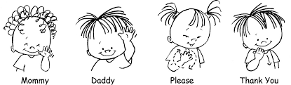

Classes include:
- ASL Activities for children ages 5-12
- Beginning ASL for Adults
- Advanced ASL for Adults

Class Fee is $30 per family
Please make checks payable to:
Bloomfield Hills Schools

Any Questions regarding the program should be directed to:
Diana Campbell, Coordinator at
diacampbell@bloomfield.org
or call 248-341-7177

