Bloomfield Hills High School
Guidance for Fall Athletics

Training/Practice
- A predetermined site/location will be explained to all athletes/participants, including entry and exit locations and procedures.
- Athletic Trainers and Athletic Administration will directly supervise athletes/participants during entry and exit.
- Entering practice, every coach/instructor, athletic trainer, and athlete/participant shall wear a mask during check-in screening
- Check-in screening has been drafted by the MHSAA and is consistent with the existing health department screening protocol.
- Athletes/participants must have a means of leaving the site/location if they do not pass the screening (parents/guardians are informed to wait until their student has cleared screening before leaving the site/location).

Athletes/Participants who Do Not Clear the Check-in Screening
- Athletes/Participants will be escorted to the exit and then to the predetermined holding location.
- If they have driven to (or have other means to return home from) the site/location, a call home from the athletic administrator will be made prior to the student leaving the site/location.
- Any athlete/participant who must leave practice for COVID-19 concern is required to go to a physician.
- A physician’s note; noting a negative COVID-19 test, is required before returning to practice. This must be returned to the athletic trainer.

Athletes/Participants who Test Positive
- Administration will gather attendance log for all practices starting 48 hours prior to the appearance of symptoms in the infected individual
- Notification of a positive test is made to:
  - Kelly Bohl
  - Patrick Watson
  - DHW
  - John Ciecko
  - Mike Cowdrey
  - Avis Najor
  - Charlie Hollerith
- Health Department (OCHD) guidelines/protocols shall be followed, including:
  - Interview of the athlete/participant who has tested positive
  - Determination of all ‘close contacts’ starting 48 hours prior to the appearance of symptoms
  - Communication to all close contacts of the requirement to isolate and/or enter a testing protocol (per WCHD)
  - Communication to all others at site/location of potential exposure

Social Distancing, PPE and Shared Equipment
- Social distancing is required at all times
- The use of PPE (specifically masks) is required during entry, exit, and any time in between if social distancing cannot be maintained.
- Shared equipment (i.e., balls, music stands) shall be cleaned by coaching staff following use, and as prescribed by the guidance of the MHSAA

Water Guidelines
- Athletes/participants are strongly encouraged to bring their own water
- Sharing of personal water bottles is prohibited
- Athletes/Participants shall maintain social distancing all times

If Guidelines are Not Followed
- The following day practice will be canceled by athletic administration

Rationale
The health and safety of our student athletes, coaches, staff, and community is our top priority. We recognize that participation in physical activity is important to the physical and social emotional well-being of our high school students. Balancing the concerns related to the pandemic with the benefits of physical activity, we have conducted outdoor athletic summer training and provide the following guidance as we transition into the official start of the fall sports season.
Under the guidance provided by the MHSAA, and informed by the existing - and developing - guidelines/protocols from the health department, all coaches/instructors have participated in training for organizing and leading athletes/participants in outdoor athletic summer training since mid-June. This training included written documents that detail the necessary precautions and required guidelines and protocols as detailed by the MHSAA.
On July 29, the MHSAA posted (mhsaa.com) overall and sport-by-sport guidance that complies with all Executive Orders from Governor Whitmer for fall sports. New competition limits in all fall sports were approved to limit the number of teams and individuals at any one competition site. For now, the concept is for fall competition to take place as locally as possible with no large-scale events, invitationals, or tournaments.

The MHSAA has allowed:
- All low-risk sports to begin practice and competition as scheduled on August 12: golf, tennis, cross country, and swimming. Swimming shall remain outdoors until pools are opened with capacity limitations being followed.
- Moderate-risk sports of soccer, volleyball (pending the opening of school gyms), and field hockey (non-MHSAA) to begin practice as scheduled on August 12 but to delay competition.
- As well, the MHSAA delayed the high-risk sport of football. Cheer and pom, both non-MHSAA sports, are placed in this high-risk category.

Spectator guidance (from the MHSAA and OAA) will be added once limits are finalized by the Governor’s office. As well, we will continue to work on guidance for transportation, use of locker rooms (prohibited at this time), and concession stands.
For BHHS, we shall proceed under the overall and sport-by-sport guidance provided by the MHSAA for football, soccer, volleyball, swim & dive, field hockey, cheer and poms, with the following guidance emphasizing and/or superseding that of the MHSAA

Football
https://www.mhsaa.com/portals/0/Documents/AD%20Forms/PACKET%20FB.pdf
Continue under outdoor (only) summer training guidelines indefinitely. No player pads or equipment are allowed. All social distancing guidelines and PPE requirements shall be adhered to. Training sessions shall be limited to 50 participants (including coaches).
There shall be no spectators.
The MHSAA anticipates a decision on competition timelines (to start or delay further) on or by August 20. Following this decision, we will reassess guidance for football.

Soccer
https://www.mhsaa.com/portals/0/Documents/AD%20Forms/PACKET%20BSO.pdf
Continue under outdoor (only) summer training guidelines indefinitely. All social distancing guidelines and PPE requirements shall be adhered to. Training sessions shall be limited to 50 participants (including coaches).
There shall be no spectators.
The MHSAA anticipates a decision on competition timelines (to start or delay further) on or by August 20. Following this decision, we will reassess guidance for soccer.

Volleyball
https://www.mhsaa.com/portals/0/Documents/AD%20Forms/PACKET%20VB.pdf
Continue under outdoor (only) summer training guidelines indefinitely. No indoor training. All social distancing guidelines and PPE requirements shall be adhered to. Training sessions shall be limited to 50 participants (including coaches).
There shall be no spectators.
The MHSAA anticipates a decision on competition timelines (to start or delay further) on or by August 20. Following this decision, as well as decisions related to opening indoor facilities, we will reassess guidance for volleyball.

Swim & Dive
https://www.mhsaa.com/portals/0/Documents/AD%20Forms/PACKET%20GSW.pdf
Continue under outdoor (only) summer training guidelines indefinitely. No indoor training. All social distancing guidelines and PPE requirements shall be adhered to. Training sessions shall be limited to 50 participants (including coaches).
There shall be no spectators.
The MHSAA anticipates a decision on competition timelines (to start or delay further) on or by August 20.
Following this decision, as well as decisions related to opening indoor facilities, we will reassess guidance for swim & dive.

Field Hockey
(non-MHSAA)
The MHSFHA (state association) has adopted the MHSAA’s soccer guidance. Continue under outdoor (only) summer training guidelines indefinitely. All social distancing guidelines and PPE requirements shall be adhered to. There shall be no contact between athletes. Training sessions shall be limited to 50 participants (including coaches).
There shall be no spectators.
We will wait to hear more from the state association regarding a decision on competition timelines (to start or delay further). Following the next decision of the MHSFHA, we will reassess guidance for field hockey.

Cheer and Poms
(non-MHSAA)
Continue under outdoor (only) summer training guidelines indefinitely. All social distancing guidelines and PPE requirements shall be adhered to. There shall be no contact between athletes. Training sessions shall be limited to 50 participants (including coaches).
There shall be no spectators.
We will wait to hear more regarding decisions on competition timelines (to start or delay further).
For BHHS, we shall proceed under the overall and sport-by-sport guidance provided by the MHSAA for cross country, golf, and tennis, with the following guidance emphasizing and/or superseding that of the MHSAA:

Cross County
https://www.mhsaa.com/portals/0/Documents/AD%20Forms/PACKET%20XC.pdf
All social distancing guidelines and PPE requirements shall be adhered to. This includes all times before and after training sessions/practices and competitions. Except when engaged in the activity, athletes shall follow all social distancing guidelines and PPE requirements. Coaches, contest management, school administrators, media, and all staff are required to wear face coverings at all times.
No indoor training. Outdoor training sessions/practices shall be limited to 50 participants (including coaches). Competitions will have limited numbers of athletes as per guidelines.
There shall be no spectators at training sessions/practices.

Golf
https://www.mhsaa.com/portals/0/Documents/AD%20Forms/PACKET%20GGF.pdf
All social distancing guidelines and PPE requirements shall be adhered to. This includes all times before and after training sessions/practices and competitions. Except when engaged in the activity, athletes shall follow all social distancing guidelines and PPE requirements. Coaches, contest management, school administrators, media, and all staff are required to wear face coverings at all times. No indoor training. Outdoor training sessions/practices shall be limited to 50 participants (including coaches).
Competitions will have limited numbers of athletes as per guidelines.
There shall be no spectators at training sessions/practices.
Tennis
https://www.mhsaa.com/portals/0/Documents/AD%20Forms/PACKET%20BTN.pdf
All social distancing guidelines and PPE requirements shall be adhered to. This includes all times before and after training sessions/practices and competitions. Except when engaged in the activity, athletes shall follow all social distancing guidelines and PPE requirements. Coaches, contest management, school administrators, media, and all staff are required to wear face coverings at all times. No indoor training.
Outdoor training sessions/practices shall be limited to 50 participants (including coaches). Competitions will have limited numbers of athletes as per guidelines.
There shall be no spectators at training sessions/practices.

Screening Protocol for Bloomfield Hills High School Athletics

- Gates Open for Temp Checks Monday - Friday at 7:15am
- Athletes with positive symptoms and/or temperature over 100.3 will be required to seek medical attention prior to return to training.
- There is absolutely no loitering after practices.
- Due to MHSAA and State rules, no bathrooms, shared water stations or athletic training services will be available during training sessions. The Athletic Training Room will be outside under the tent.

- Students are to arrive with their mask on (required) and a bag with equipment, water and personal sanitizer.
  - Per MHSAA/NFHS Guidelines and district guidelines, No spectators will be allowed.
  - All Coaches MUST wear a mask throughout the whole practice session. Coaches can remove their mask while distanced.
  - Students will not be allowed to re-enter once entered the stadium area for training.
  - Masks are not necessary during training, however MUST be worn during off times.
  - Mask, water, equipment and personal belongings are to be kept in designated rest zones. (Fig 3: Rest Zones)
  - Clothes must be worn the entire training session.
  - Following day practices WILL be canceled if guidelines are not followed.

- Once the student leaves their car, or is dropped off, they are to enter the stadium through the ticket booth area from the stairs only. Students can access the field via the gate to the west of the ticket booth.

- STADIUM ENTRANCE:
  - Step 1: All students and staff are to complete the Symptom Screen QR Code. Once completed, proof of completion is necessary to advance to the next step.
  - Step 2: Temperature Check and Hygiene Station” (Fig 1: Steps)
    - Social Distance MUST be maintained while entering the stadium.
    - If a student does not have a phone, they may complete the Symptom Monitoring Form at Temp/Hygiene Area.
    - Students will then have their temperature checked and hands sanitizer will be available.
  - Step 3: Students will need to have a stamp on their hand for clearance into the stadium/training.
- Students must follow the Field Flow Chart (Fig 2: Field Flow)
- Rest Zones are designated on the south side of the track.
  - Students are not allowed in other students' rest zones and must keep equipment in their zone during the whole training session.
  - Coaches MUST monitor this.
- Once the session is over, students are to exit the field on the East end. They will go through the large gates, up the ramp, and out to the parking lot. (Fig 1: Steps)

4. STADIUM EXIT: All students are to exit the stadium through the Temp/Hygiene area but up the ramp. Each student or staff member MUST sanitize their hands as they exit.

Figure 1: Steps to Enter and Exit Stadium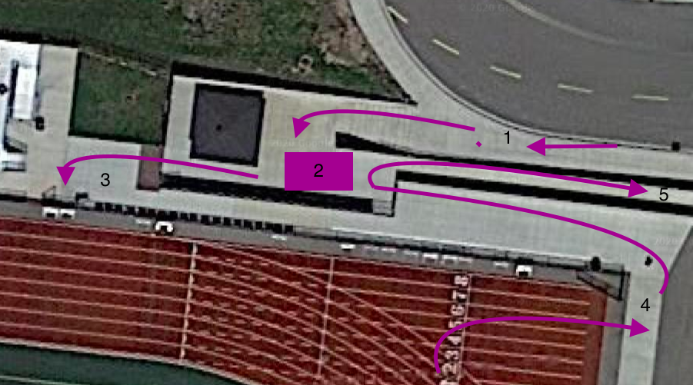

Figure 2: Field Flow
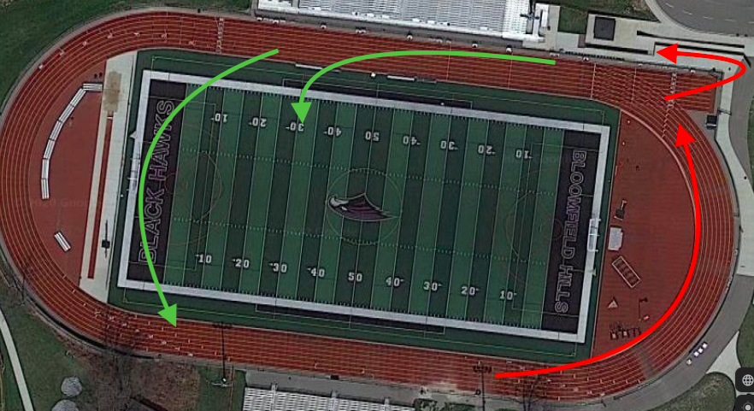
Figure 3: Rest Zones
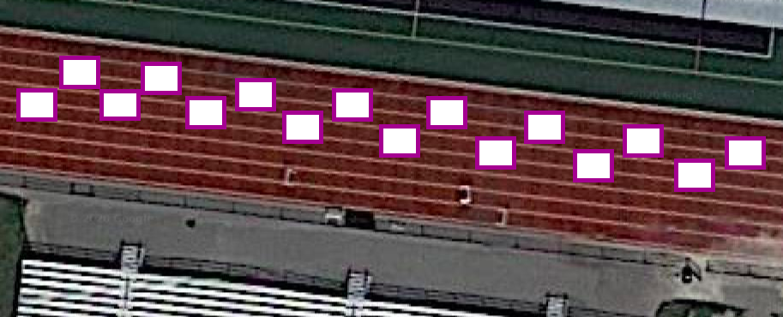

Figure 4: Practice Locations
