To access your child’s online report card:
Log in to Parent Portal on www.bloomfield.org
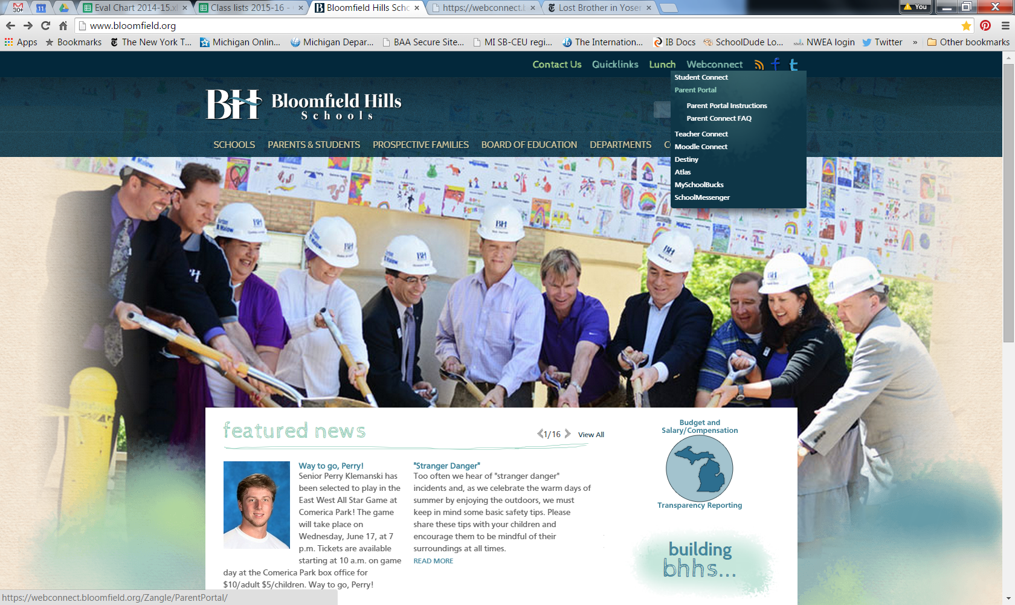
Once you are logged in, click on your child’s name to access their profile.
To view your child’s grades and comments, click on Marks and Standards on the left side bar.
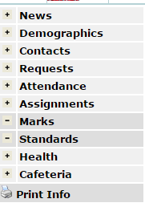
To generate a PDF of your child’s report card for printing or saving, click on the link above and to the right of your teacher name in the Marks section. It will be titled “January 2016 Report Card.”

